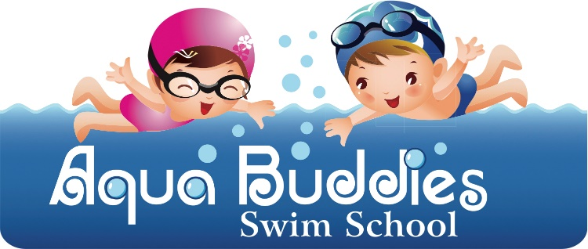
Aqua Buddies Swim School phone: 772-626-9291
2755 SW Buckhart Way website: aquabuddiespsl.com
PSL, FL 34953 email: aquabuddiespsl@gmail.com
Aqua Buddies Swim School Registration Form

Parent/Guardian # 1: ________________________________ Occupation: _____________________
Address:____________________________________________________________________________
Home Phone: ______________________________ Cell Phone: _____________________________
Email Address: _________________________________________

Parent/Guardian # 2: ________________________________ Occupation: _____________________
Address:____________________________________________________________________________
Home Phone: ______________________________ Cell Phone: ______________________________
Email Address: _________________________________________
Student First and Last Name: ___________________________________ Nickname: _______________
Primary Physicians Name and Phone: ____________________________________________________
Date of Birth: _____________ Gender: ____________ Siblings: ___________________________
Previous Swim Training: _______________________________________________________________
How did you hear about Aqua Buddies Swim School? ________________________________________
List any and all physicians including specialist your child has seen or is scheduled to see (excluding well child visit checkups) as well as any physical exceptions, (examples asthma, acid reflux, seizures, prone to ear infections etc.)? ____________________________________________________________________
_____________________________________________________________________________________
Page 1

I give permission for me/my child to participate in aquatic activity/training. I/my child am/is in good health and physical condition and am/is not suffering from any condition that would prevent me/my child from engaging in this activity.
Photographs and video may be taken by Aqua Buddies Swim School in conjunction with lessons. I understand and agree that they may used for informational and advertising purposes. Aqua Buddies Swim School respectfully request that no videos be taken by parent/guardians at any lesson until graduation week. Photographs maybe taken during the program with permission from the swim instructor conducting the lesson.
Initial: __________

Please read carefully and be aware that in registering your minor child for participation in this program you will be waiving and releasing all claims for injuries you or your child might sustain as a result of participation in any class or activity conducted by Aqua Buddies Swim School, by its agents or instructors. As a parent/guardian of a participant in Aqua Buddies Swim School, I recognize and acknowledge that there is certain risk associated in swim activities and training. I agree to assume full responsibility of any injury, property damage, or loss which I or my minor child may sustain as a result of participating in any and all activities connected with or associated with Aqua Buddies Swim School. I agree to not hold Aqua Buddies Swim School from liability resulting from the use of premises waive and relinquish all claims against Aqua Buddies Swim School facility. This includes the owners and instructors from any claims or injuries that I or my minor child may sustain as a result of participating in any Aqua Buddies Swim School program(s). I have read and fully understand the above waiver and release the above named (facility, owners, instructors, etc.) from any and all claims, and it shall not be modified.
_________________________________________ __________________
Parent Signature Date

Page 2

Policy and Procedure
Survival Swim Training
- Classes are held Monday through Friday, in 10-15-minute increments. (timing is at the instructor’s discretion).
- It is the responsibility of the parent/guardian to be on time to the lesson. Lessons are prescheduled and cannot run over to make up for late arrivals.
- Classes are typically 4-6 weeks. Please note that all children are individuals and we cannot predict exactly how long it will take your child to complete the program.
- Upon graduation from Survival Swim it is discussed between the parents and the instructors on maintenance lessons. We offer maintenance lessons 1, 2 or 3 times a week.
- Refresher Classes are recommended at least once a year. Refresher classes typically take 1-2 weeks. Again, this is depending on how much practice your child has had in the pool and each child as an individual.
- If a child has a diaper accident in the pool and it is not contained, Aqua Buddies Swim School is legally required to shut down for the remainder of the day and treat the pool. Aqua Buddies Swim School will make every effort to contact you as soon as possible to notify you of your cancelled lessons. Please be aware that this could be anyone one of our children at any given time. Aqua Buddies teaches infants and children and we need to be sensitive to this issue. There will be no credits or make up lessons when this situation arises.
- Please refrain from feeding your child one to one and a half hours prior to lessons.
- Aqua Buddies Swim School will have paid closed holidays during each Calendar year: New Year’s Day, Good Friday, Memorial Day, 4th of July, Labor Day, Thanksgiving Day and the day after Thanksgiving, Christmas Eve and Christmas Day. If Aqua Buddies Swim School chooses to close any other days surrounding these holidays you will not be charged for any additional closed days.
Initial: __________
Page 3

Missed Lessons/ Sick Policy

- If you know that your child will be out, please inform your instructor right away. Unfortunately, because we work in a pool with little children, we cannot always reply to you immediately. You can leave a message with the front office at 772-626-9291.
- If an instructor or Aqua Buddies Swim School cancels a lesson you will be fully credited on the following weeks invoice.
- If you miss a lesson it is considered a missed lesson, there will be no credit or make up lesson.
- If your child is sick and cannot attend lessons, you will be charged your regular weekly rate. You pay for your time slot, not attendance. For the safety of our students and instructors, children must be fever/symptom free (without medication) for at least 24 hours before returning to lessons. If your child is not fever/symptoms upon returning to lessons, the instructor will not resume lessons. Please understand the safety of all our students and instructors are our upmost importance. It is at the discretion of our instructor to request a doctor note to return to lessons.
- If your child contracts any communicable childhood disease (chicken pox, hand foot mouth, measles, etc.) you must notify Aqua Buddies Swim School immediately. You must also provide a written note from your pediatrician in order to resume lessons.
- If your child gets sick and must miss consecutive days, you have the option to hold your time slot by continuing to pay your normal regular weekly rate. If you choose to remove your child from the program during recovery time without paying the regular weekly rate you will be placed back on the waiting list.
- Please remember that upon reserving your time slot you are reserving the time of that instructor and your payments are based upon that and not attendance. There will not be any credits for missed days, sick days or vacation days, nor will there be any makeup lessons.

Initial: __________

Page 4

Swim Diapers
- All Children who are not potty trained currently or have not been potty trained for longer than 6 months must wear both disposable and reusable swim diapers. If both are not on at time of lesson, the lesson will be unable to occur. There is no exception to this rule.
- If your child has an accident in the pool and it is contained in the diaper, upon you realizing this you must notify your swim instructor immediately.
- You can purchase both disposable and reusable diapers from Aqua Buddies Swim School at the following rates. Reusable diapers are $12.00 and disposable swim diapers will be $1.00, you will be billed on the following weeks invoice for the swim diapers. If it is your last week of the program you will receive an additional invoice which must be paid prior to graduation.
- All swim diapers must fit appropriately. There is a “Two Finger Rule” for swim diapers, if you can put more than two fingers between the leg of the child and the diaper it is not a proper fit. If you cannot than it is a proper fit.
- Please do NOT wring out reusable diapers into the pool. This is unsanitary, you can use the restroom or the exterior of the facility for this purpose.

Parking
- Please note that there is limited parking in front of our facility, and we request that you only arrive a few minutes prior to your lesson to prepare for your lesson.
- We request that at the end of your lesson you change your child in a timely manner to free up parking for the next client.

Initial________
Page 5

Pricing and Payments
Rates:
- Roll-Over-Float- $85.00 weekly rate for Monday to Friday once a day lesson.
- Swim-Float-Swim-$85.00 weekly rate for Monday to Friday once a day lesson.
- Refresher Classes- $85.00 weekly rate (2 weeks minimum unless instructor deems one week is sufficient based on skills performed), Monday to Friday once a day lesson.
- Stroke lessons and other swim programs coming soon and TBD on an individual program plan
Two Week Maintenance Program:
- 2 Lessons $40.00 (to be used 1 time a week for 2 weeks $20.00 each lesson)
- 4 Lessons $65.00 (to be used 2 times a week for 2 weeks $16.25 each lesson)
- 6 lessons $85.00 (to be used 3 times per week for 2 weeks $14.17 each lesson)
Maintenance lessons will renew every two weeks until a two-week written notice is given to the front office
Registration Fees
- Returning Clients $25.00 for the 1st child and $15.00 for each additional child in the family.
- New Students $50.00 for the 1st child and $75.00 for 2 more children.
- All Registration Fees are occurred on a calendar year bases.

Initial_________
Page 6

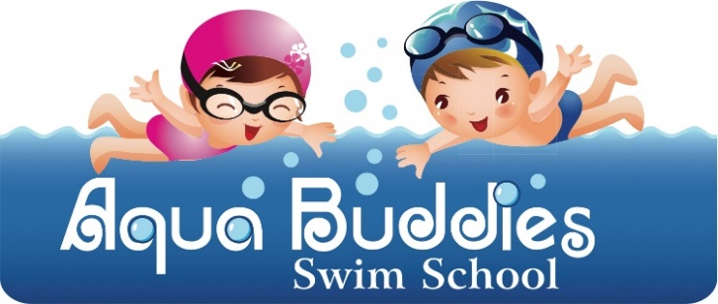
Pricing and Payments
- You are required to pay the registration fee and the 1st two weeks of lessons at the time of registrating. On the 3rd week you will be billed for an individual week and every week going forward the same.
- We accept Visa, Mastercard & American Express, we will no longer be accepting cash or check. All payments will be invoiced the weekend prior to swim lessons for the following weeks lessons. All invoices must be paid by 8am the morning of the start of the week.
- Any Payments that are not paid prior to Mondays lessons will be subject to a $25.00 late fee and must be paid with the current invoice in order to continue lessons for the week. Any Invoice not paid by Tuesday at 8am will cause lessons to be suspended. This could cause your slot to be given to someone from the waitlist.
- Please understand that we are in the business of teaching survival swim and additional swimming lessons, not chasing down payments. We understand that these policies are strict and firm so that our focus can be strictly on your child and the program we are teaching.
- Upon withdrawing from the program early a one-week written notice is required.
__________________________________________ _________________
Parent Name (Print) Date
__________________________________________
Parent Signature

__________________________________________ _________________
Instructor/ Owner (Print) Date
__________________________________________
Instructor/ Owner
Page 7

